Niagara Street Elementary School
3 Instructional Classroom Look Fors

- Post and refer to student Learning Targets daily.

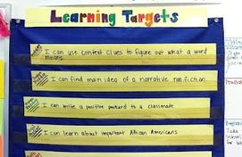

- Teacher uses one highly engaging student strategy per lesson.



- Continuous checks for understanding during each lesson.



